(1) Explode, (2) Weight Back, (3) Finish Tall

by Gerald Warner, Softball Pitching Instructor


There are three primary phases of the pitching sequence
that contribute to the speed and control of the pitch.

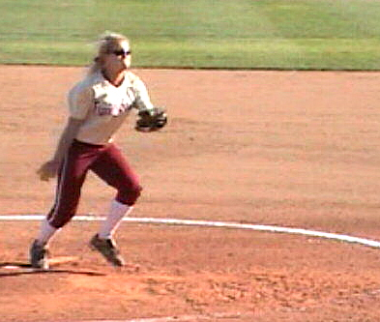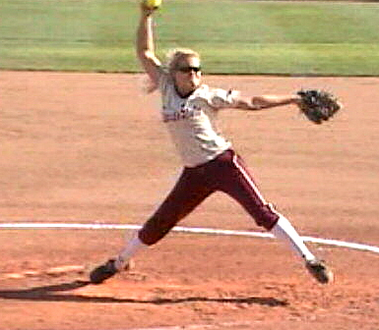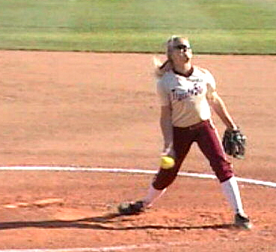
Explosive drive off the rubber Weight back on the downswing Pushback on the stride leg
These are the common elements of virtually every high-velocity pitcher. Many sequence photos in this article were selected at random from an analysis of pitchers from 12 to 21-years old.


THE DRIVE OFF THE PITCHING RUBBER… “EXPLODE” -
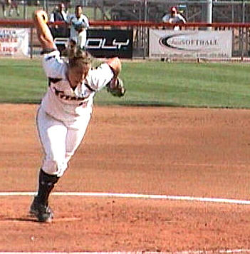
Similar to a sprinter coming off the starting blocks, it is the speed of a pitcher’s drive off the rubber that lays the groundwork for a fast pitch. Although many pitchers are told to focus on the length of their stride, explosive speed is essential. A pitcher needs to feel that she has a “spring” in her pushoff leg, so when she transfers her weight from her back leg to the front leg and leans into the pitch, she can drive fast off the rubber.
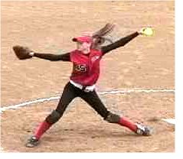
“REACH BACK” THROUGH THE DOWNSWING –
Many pitchers make a larger arm circle by reaching back (toward 2nd base) as they reach the “open trunk” halfway point in their arm rotation. As seen here, it is common for a pitcher to actually tilt her upper body backwards and reach back toward 2nd base to get a larger, better “whip” of her arm down through the release of the pitch.

FINISH TALL WITH GOOD PUSHBACK RESISTANCE –

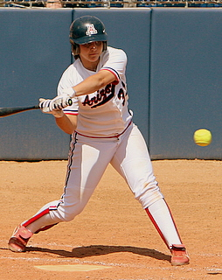
The same resistance that a hitter gets from her front leg at the point of contact, a pitcher needs to “set up a wall” and use her stride leg as the resistance for the final downswing into the release of a pitch. At the release point the pitcher’s: (1) landing leg is straight at a 15 to 25 degree angle, (2) upper body is erect, and (3) well back from the front foot,
(4) shoulders are three-fourths (or less) closed,
and (5) hips are halfway (or less) closed.

(1) Explode, (2) Weight Back, (3) Finish Tall (page 2)

Here are more examples of experienced pitchers, each of whom has excellent pitch speed, showing:

(1) her body lean and low explosive pushoff to get a fast drive off the rubber
(2) the extra “reach back – weight back” effort she puts into her downswing
(3) the “strong front wall” resistance that her landing leg provides, and finishing tall

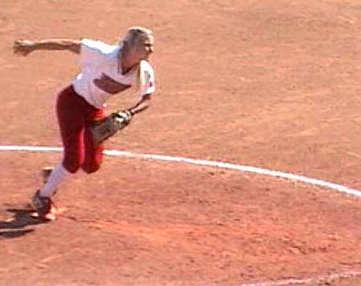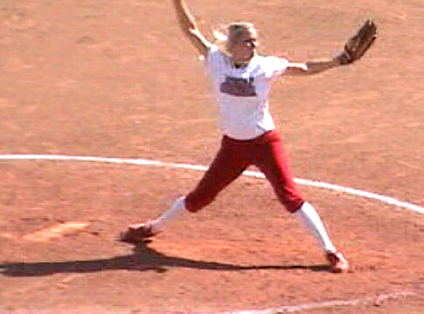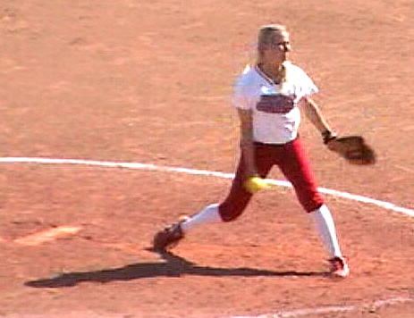

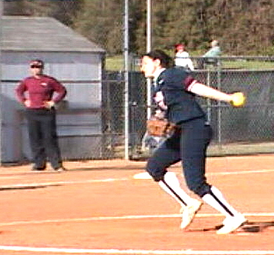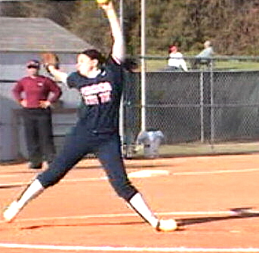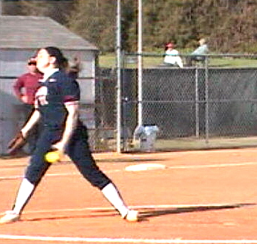

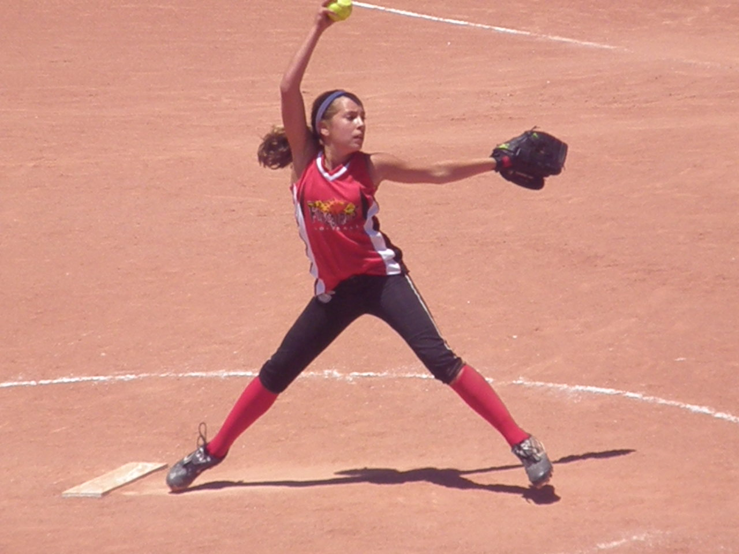

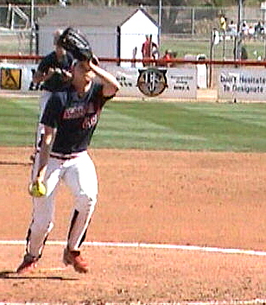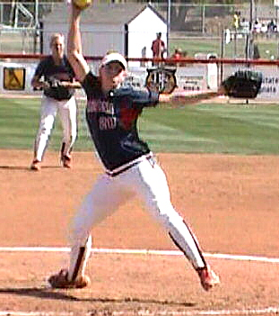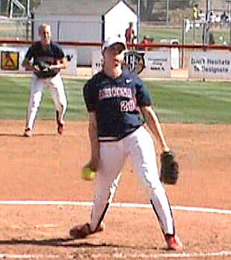

If you have questions or need more information
E-mail us at: gw@pitchsoftball.com or call Pitching Instructor Gerald Warner in Denver at (720) 200-4575

